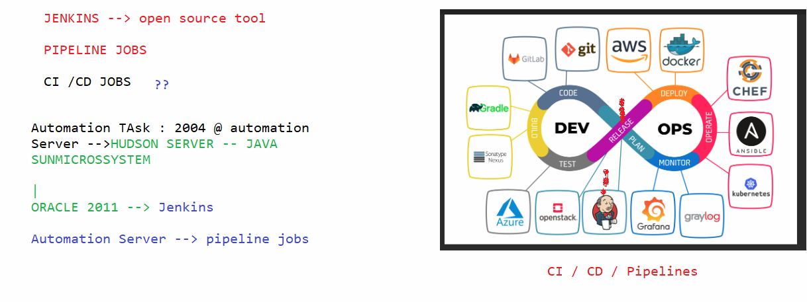

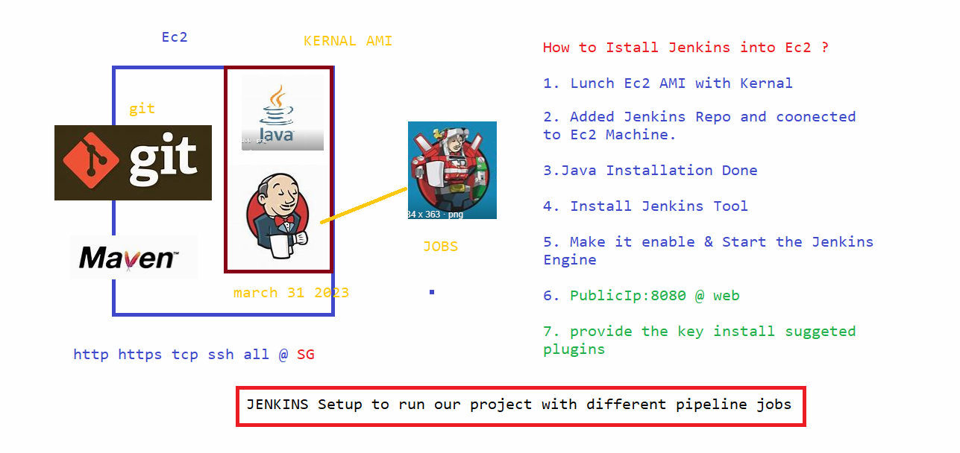

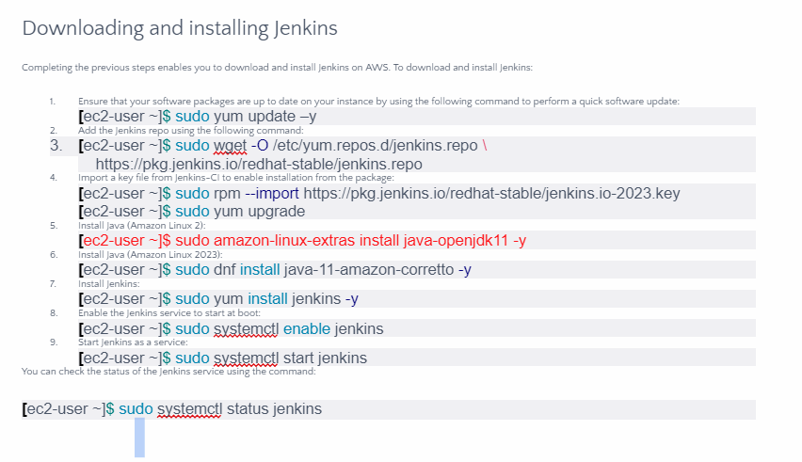

++++++++++++++++++++++++++++++++++++++++++++

Commands :

[ec2-user@ip-172-31-15-23 ~]$ history

1 clear

3 sudo yum update -y

4 sudo wget -O /etc/yum.repos.d/jenkins.repo https://pkg.jenkins.io/redhat-stable/jenkins.repo

5 sudo wget -O /etc/yum.repos.d/jenkins.repo > https://pkg.jenkins.io/redhat-stable/jenkins.repo

6 sudo yum upgrade

8 clear

9 java --version

10 sudo amazon-linux-extras install java-openjdk11 -y

11 java --version

12 clear

13 sudo yum install jenkins -y

14 clear

15 sudo systemctl enable jenkins

16 sudo systemctl status jenkins

17 sudo yum install jenkins -y

18 sudo rpm --import https://pkg.jenkins.io/redhat-stable/jenkins.io-2023.key

19 sudo amazon-linux-extras install java-openjdk11 -y

20 sudo yum install jenkins -y

21 sudo systemctl enable jenkins

22 sudo systemctl start jenkins

23 sudo systemctl status jenkins

24 clear

25 sudo cat /var/lib/jenkins/secrets/initialAdminPassword

26 history

[ec2-user@ip-172-31-15-23 ~]$

+++++++++++++++++++++++++++++++++++++++++++++++++

<http://13.126.225.160:8080/>

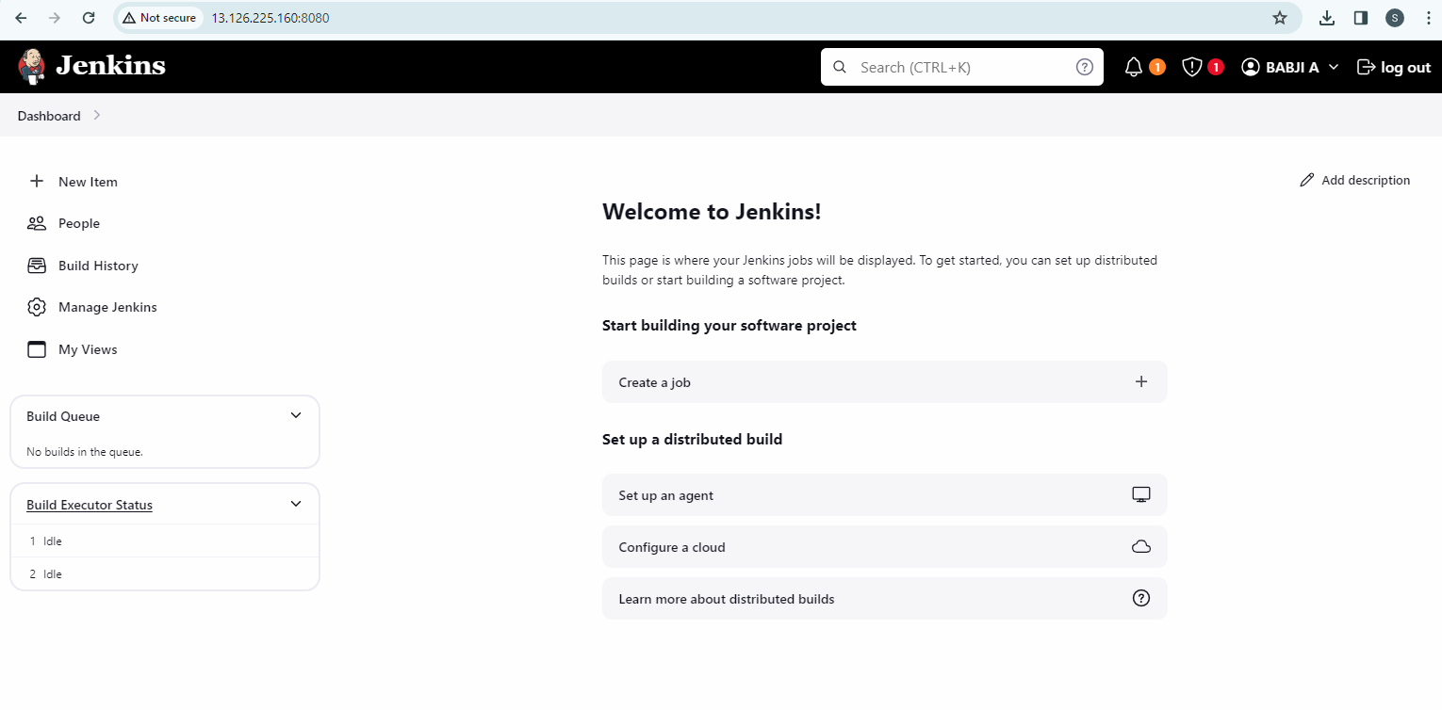

How to run 1st JOB in Jenkins :

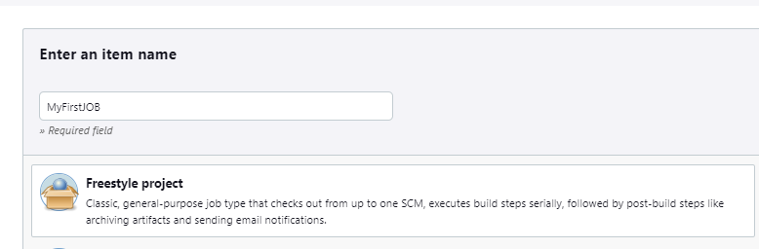

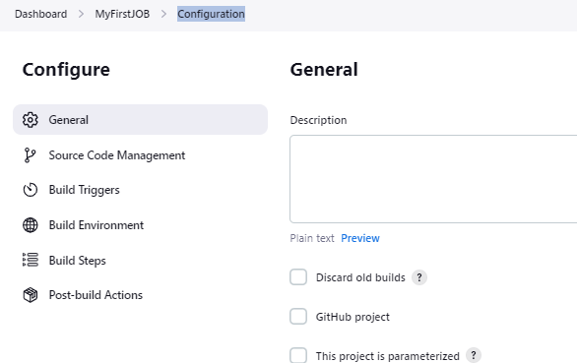

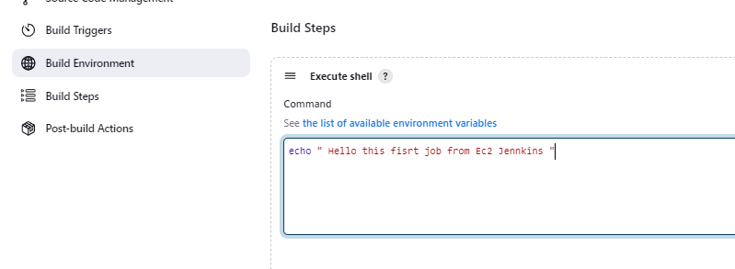

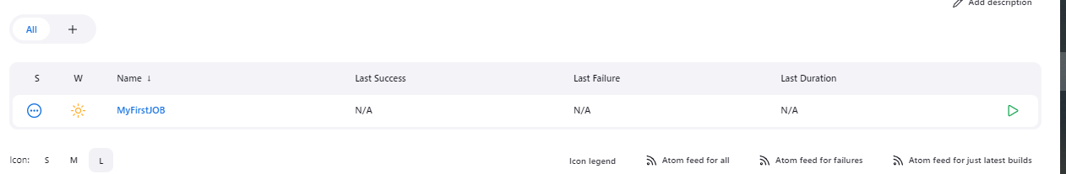

Once Run the JOB, you need to refresh the Jenkins.



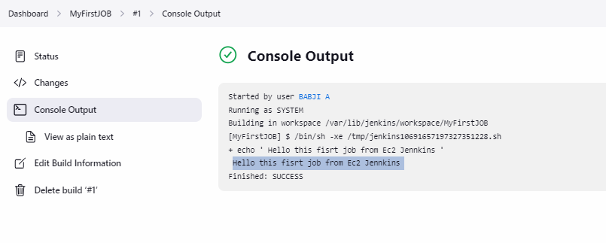

+++++++++++++++++++++++++++++++++++++++++++++++

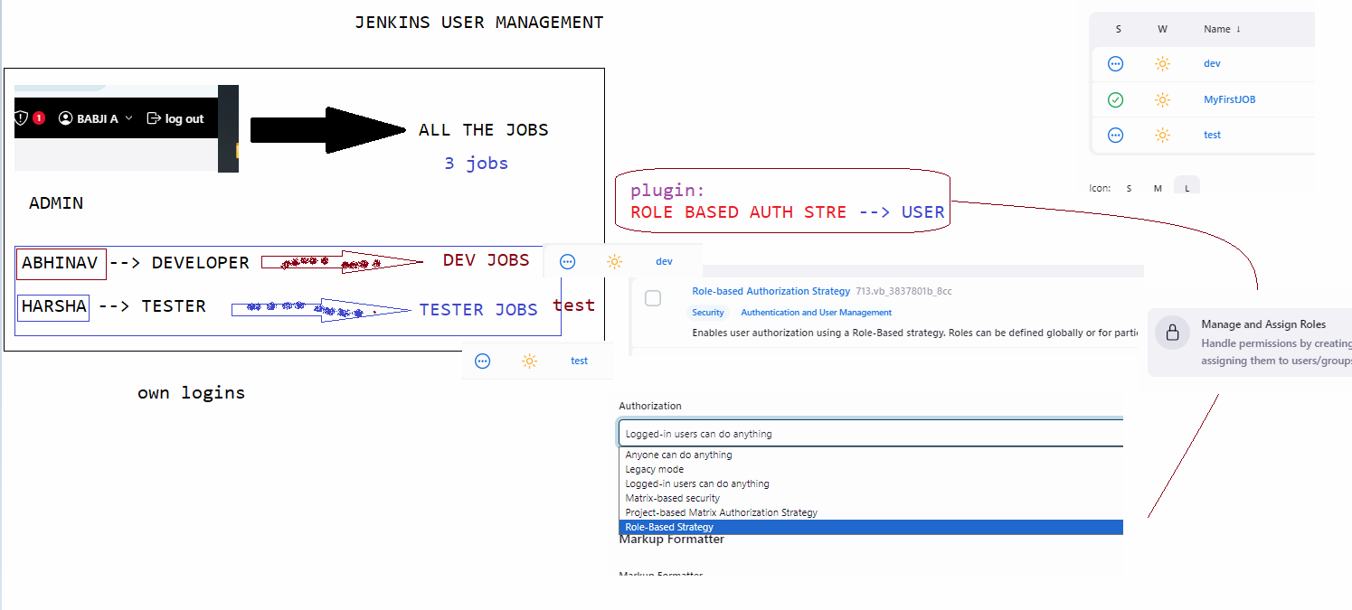

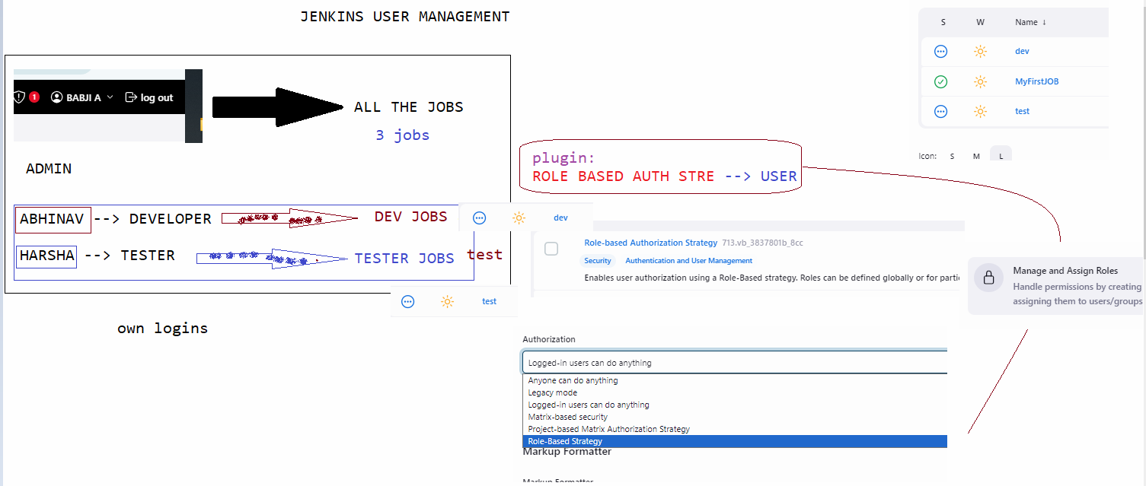

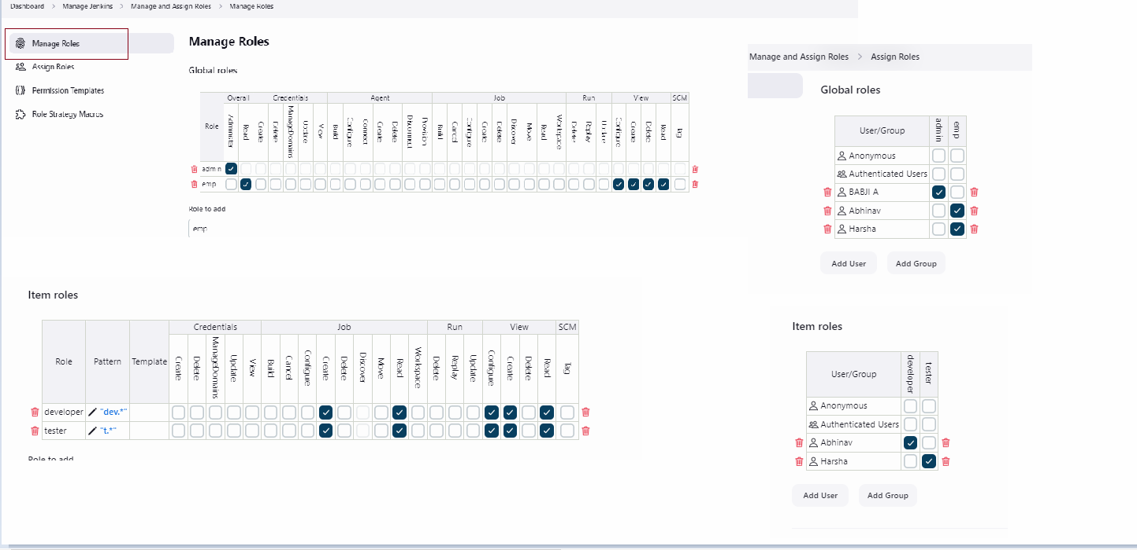

Email Triggering :

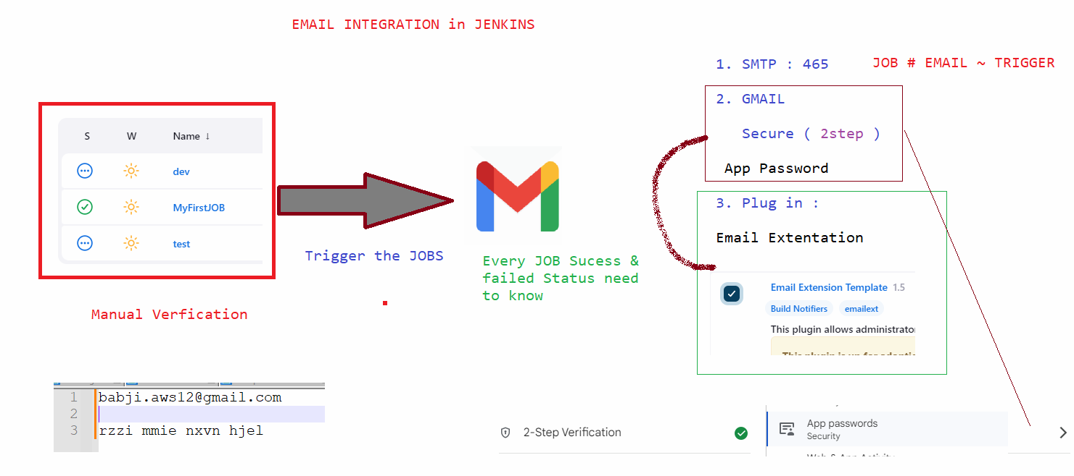

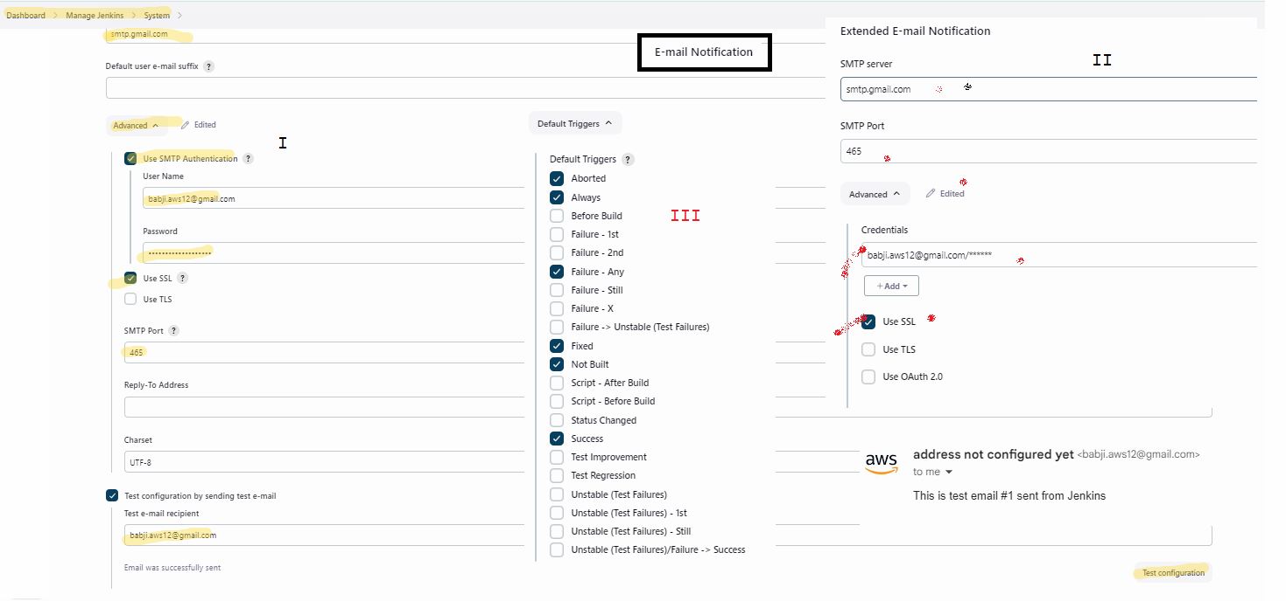

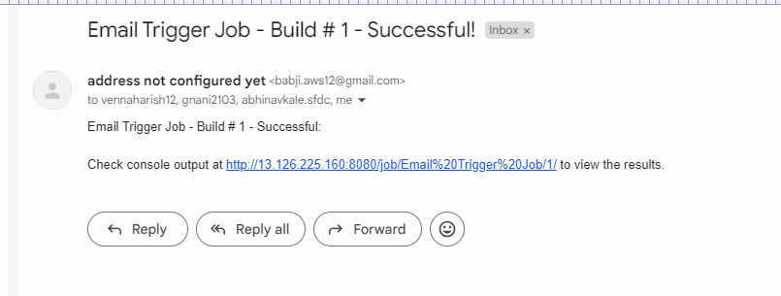

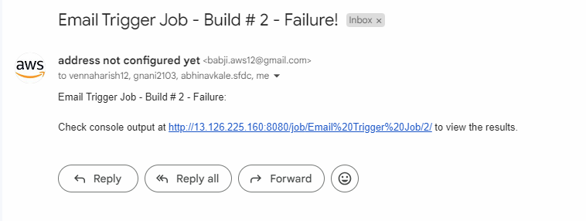

Pipeline JOBS & Scripting …